Estimation Of Business Expenses

Submitted by

Team id

NM2023TMID25712

Team members id

8AB55623A9F5B3B88B141953E8CF8558

67BEB56B72F2F7698BD40CEE574E17B0

9B6013B6D647F4E825D441C7430A2B1E

D23C1FF9879F93CB96A43B1E32C44C87

Under the guidance of

Dr . A. Beulah Mary

Assistant Professor

Department of Physics

Sri Meenakshi Government Arts College For Women(A)

Madurai-625 002



October 2023

Estimation Of Business Expenses

1, Introduction

1.1 Overview

\*The process of forecasting the financial and other resources needed to complete a project within a defined scope.

\*The process of forecasting the expenses that must be incurred to manufacture a product.

\* This involves estimating all the expenses required to start and operate the business, such as equipment, rent, inventory, and marketing. By calculating these costs upfront, business owners can better plan their budget and avoid unexpected expenses.

1.2 Purpose

\*Use :Estimates are important because they allow businsses to set expectations for their customers. They also help businesses determine whether or not a project is feasible and how much profit they can expect to make. Estimation also allows businesses to plan for unforeseen expenses and keep track of spending.

\* Acheivements by using this: Business expenses need to be considered ordinary and necessary for them to be tax- deductible

\*Business expenses are recorded on an income statement.

\* Estimates are important because they allow businesses to set expectations for their customers. They also help businesses determine whether or not a project is feasible and how much profit they can expect to make. Estimating also allows businesses to plan for unforeseen expenses and keep track of spending.

2,Problem Definition and Design Thinking:

2.1 Empathy map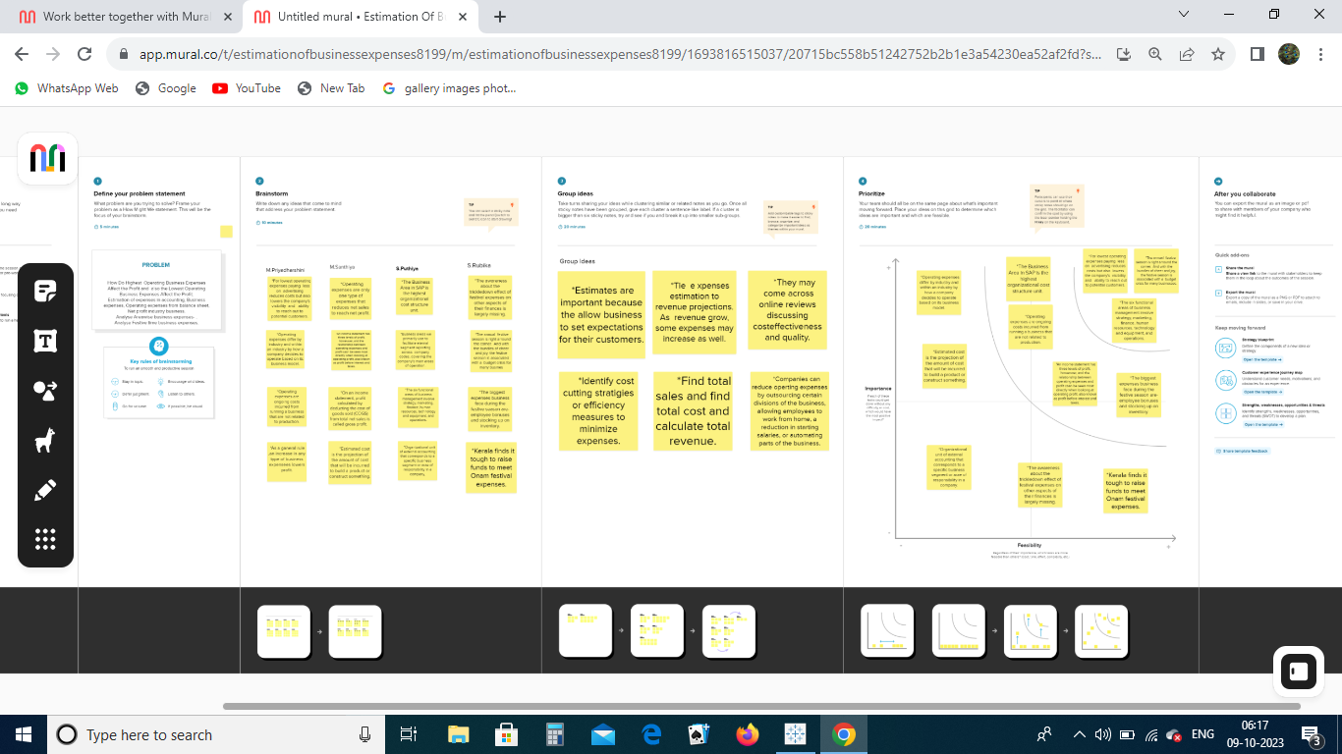

2.2 Ideation and Brainstorming map: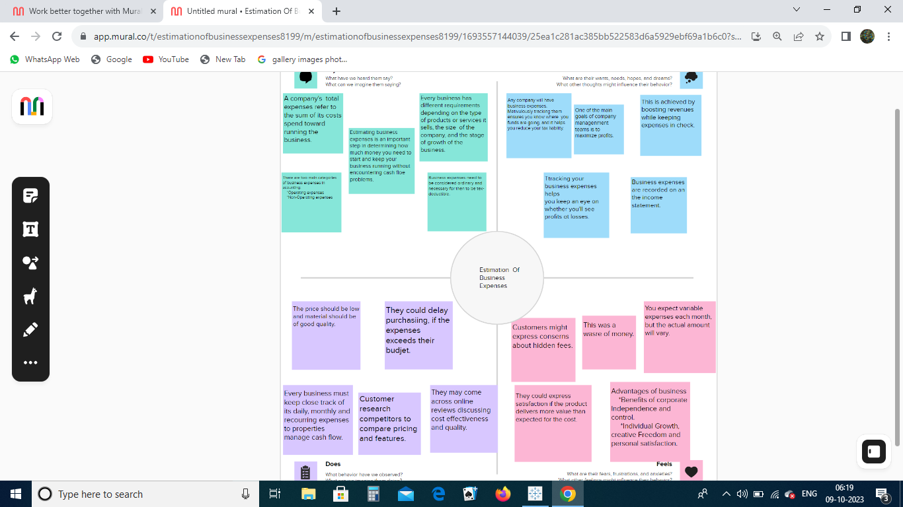

3,Result:(output of the project along with screenshot)

1. Annual Payroll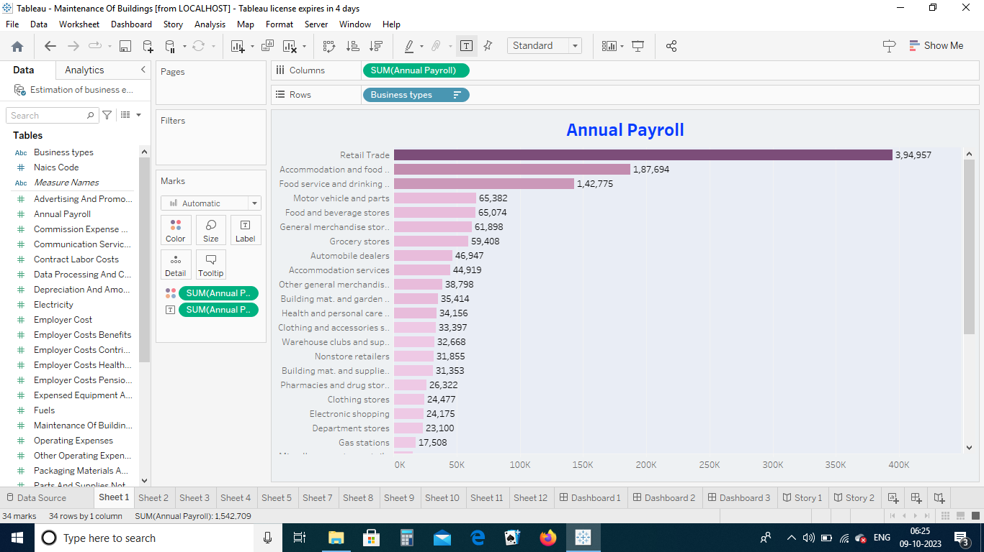

2.Advertisement Costs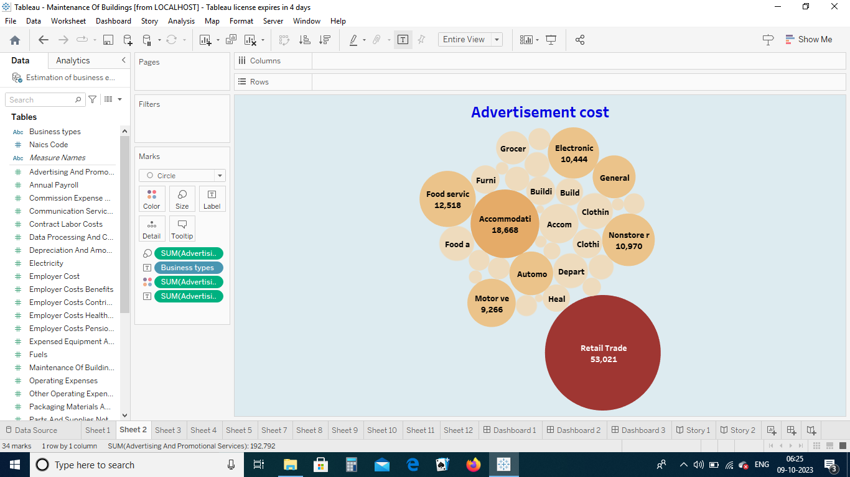

3, Contract Labour vs Employee

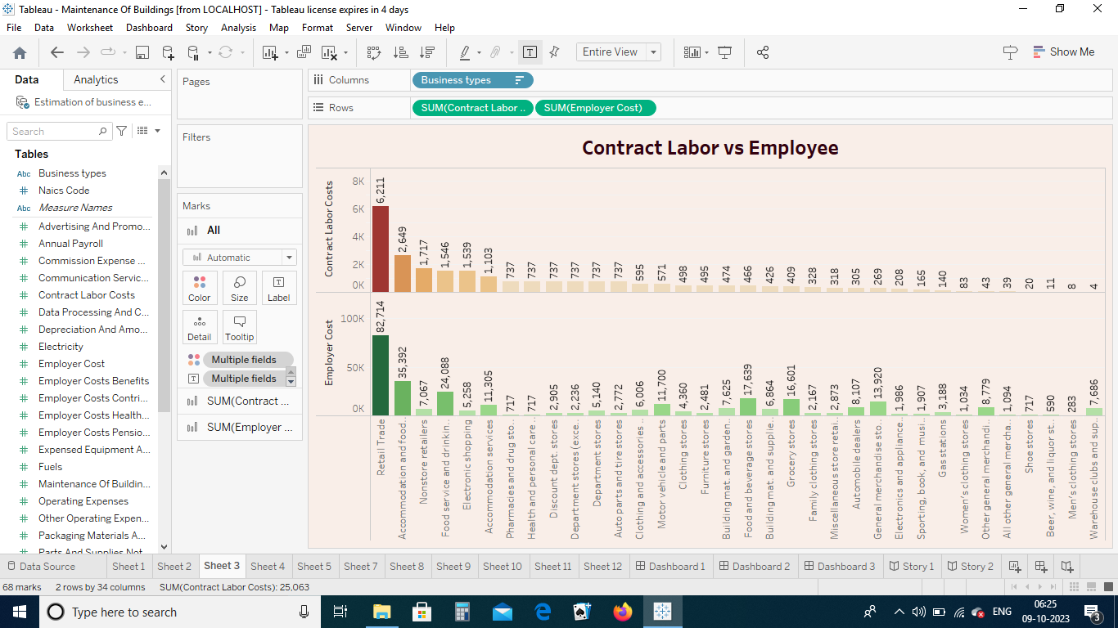

4, Employee (Insurance vs Pension)

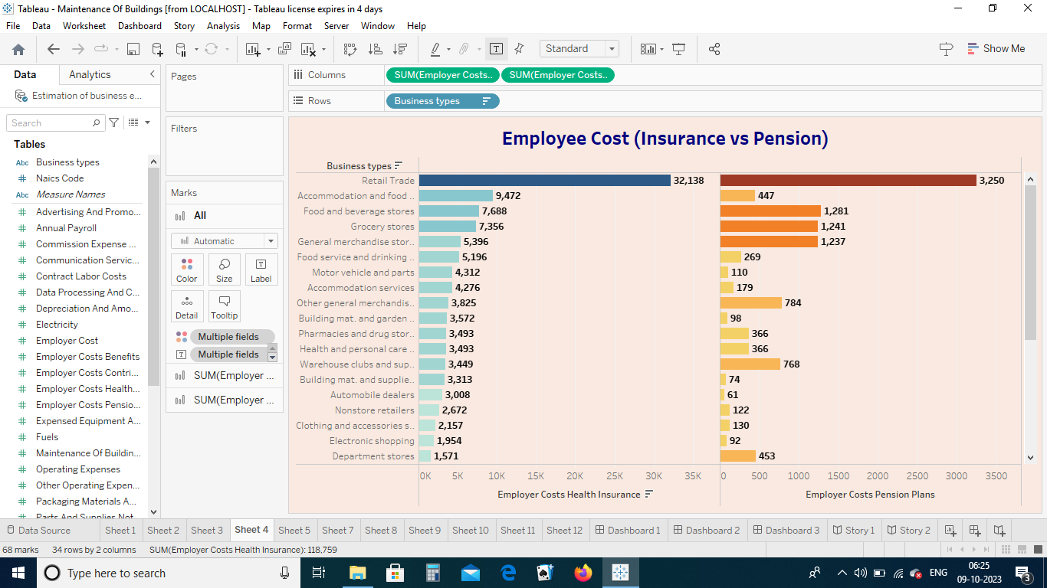

5, Equipment Costs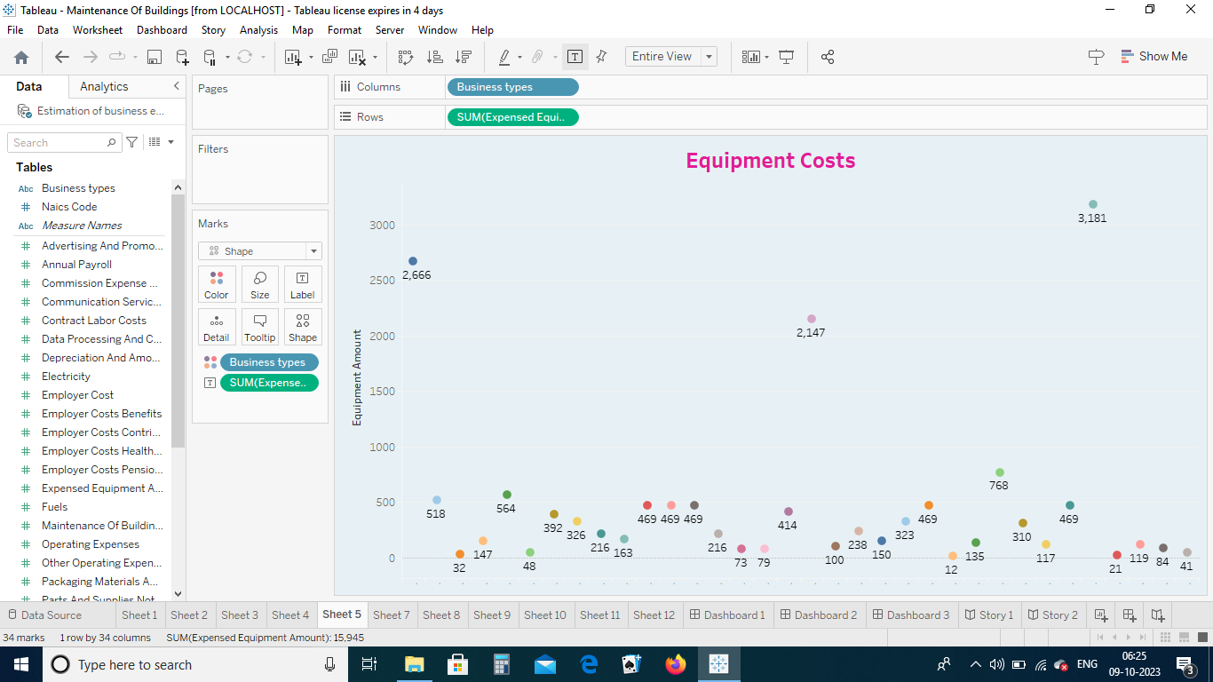

6, Fuel

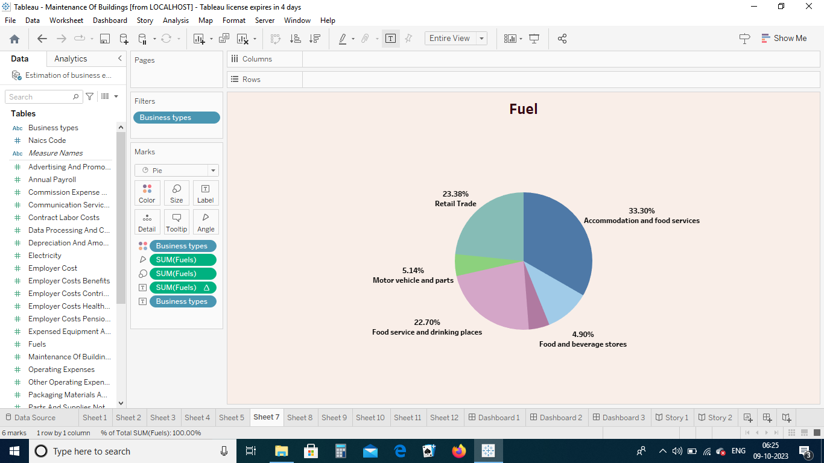

7, Maintenance Of Buildings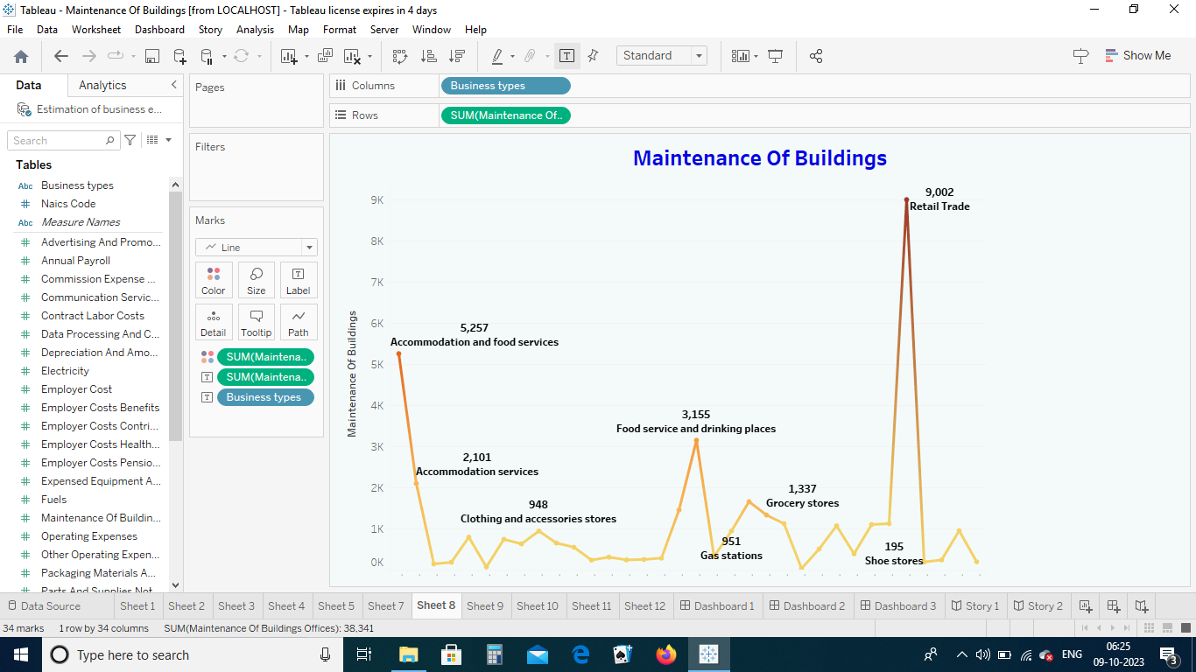

8, Power Expenditure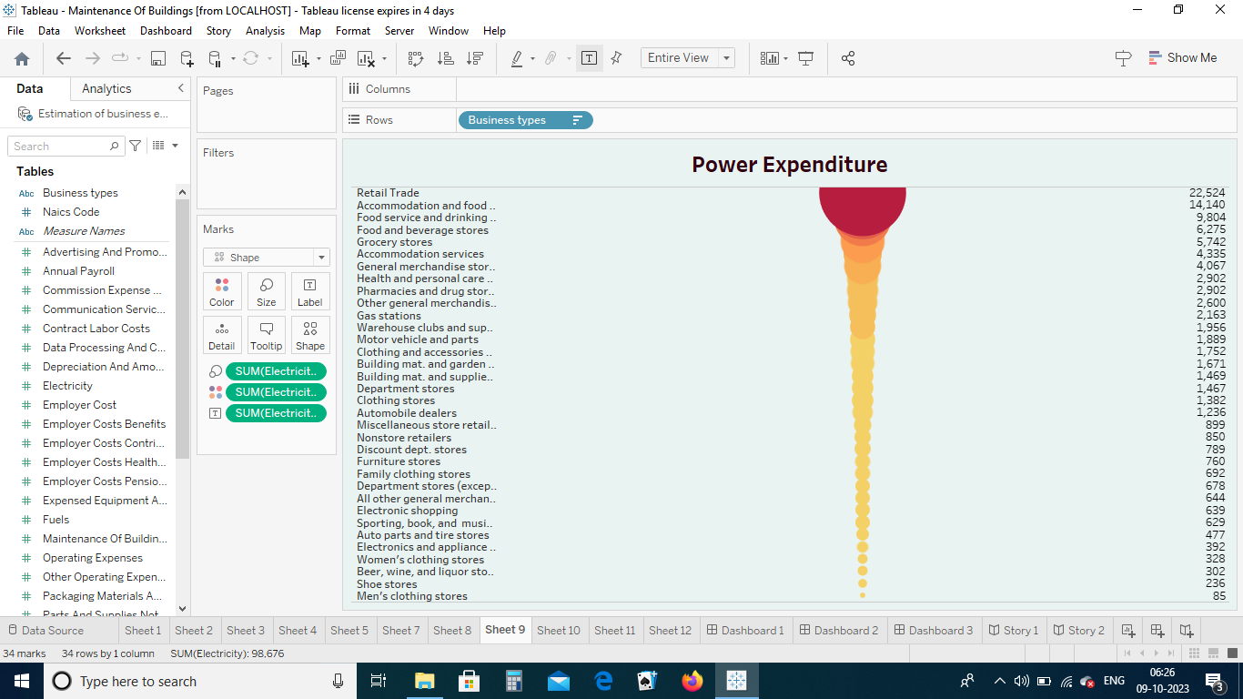

9,Rental Payment Machinery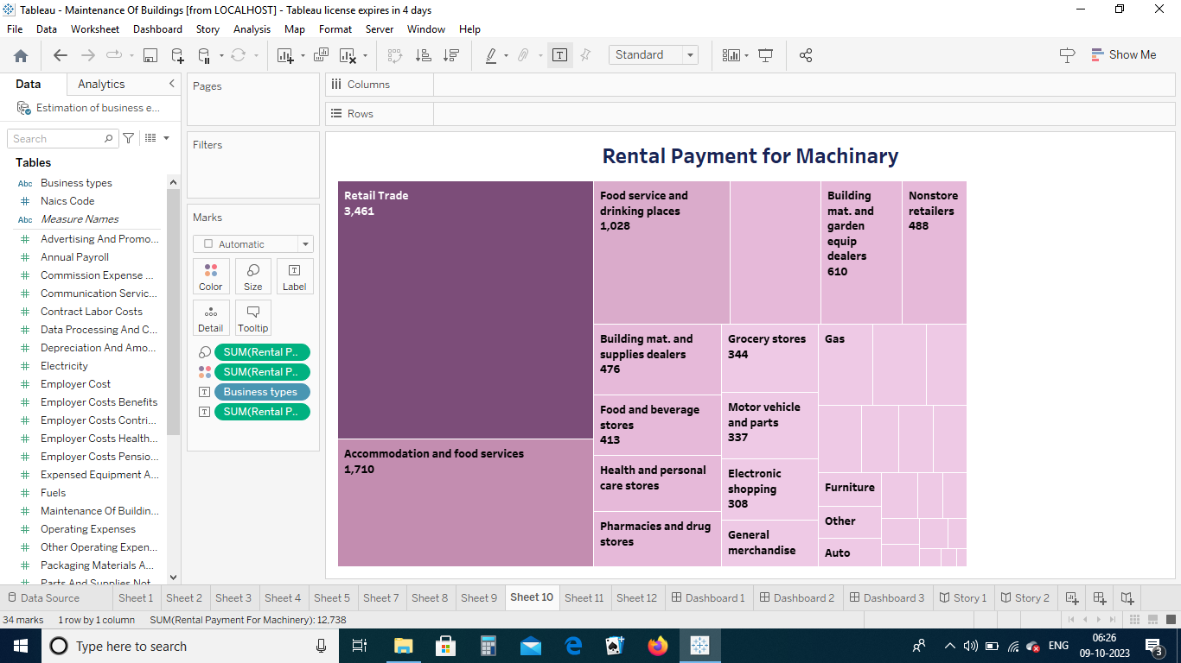

10,Taxes & Licenses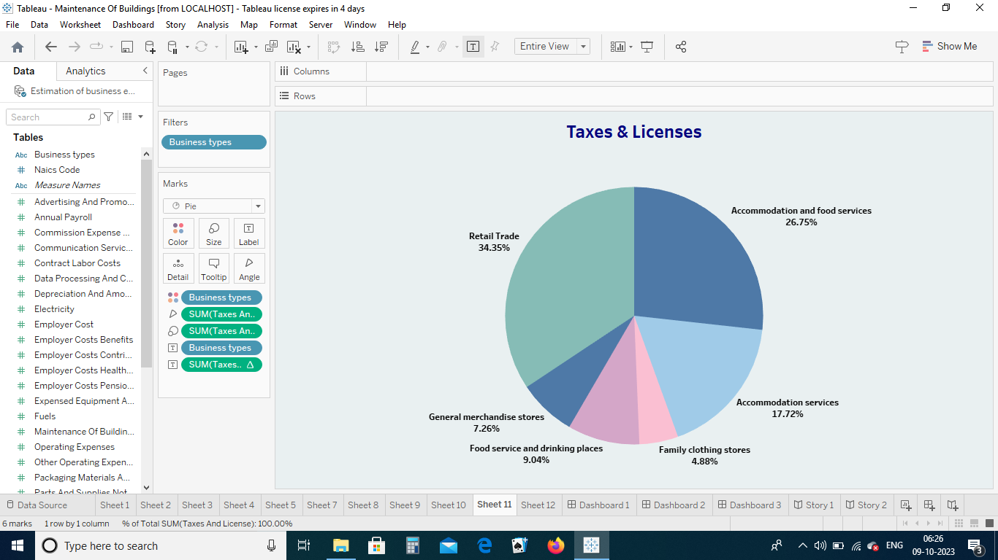

11,Transportation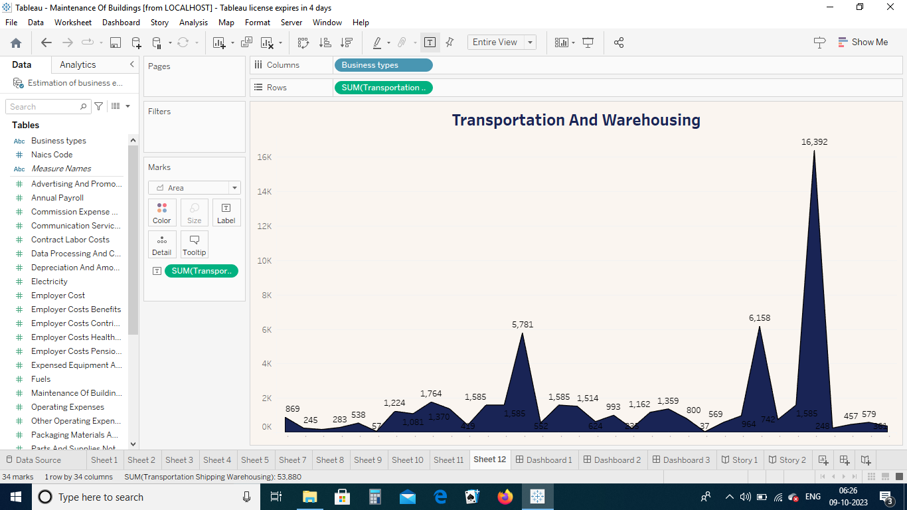

ADVANTAGES & DISADVANTAGES

Advantages

1, Save Money on Projects

\*More accurate estimations result in smoother execution of the project. So you are spared last minute overheads, unforeseen expenditures and blocked working capital. What this means are lesser project costs.

2, Complete projects Faster

\*The right estimation means glitch free, uninterrupted project execution. Projects get completed faster, better.

3, Convert More Bids

\*The best way to inspire confidence is show correct, reliable estimations. And when you inspire confidence, your bid conversion ratio goes up.

4, Work Simple

\*Bid farewell to tedious, complicated and error prone methods with the clean, user friendly interface offered by ESTIMATE.

5, Be Flexible

\*Accommodate sudden inputs, last minute information and ongoing developments with a never before ease as the software brings you highly flexible provisions.

6, Work Together

\*The software enables collaborative processes. So people in office, at sites and across locations can share their inputs on an ongoing basis to lend the project a real time advantage.

Disadvantages

1, Costs

\*The benefits of cost accounting come with a price. Since costing methods differ from organization to organization, it's not clear how these costs might manifest themselves until a specific firm is examined.

2, Complexity

\*Generally speaking, complex cost accounting systems require a lot of work on the front end, and constant adjustments need to be made for improvements.

3, Additional Steps to Verify Accuracy

\*Even if the rigidity of financial accounting creates some inherent disadvantages, it does remove the uncertainty and misapplication of accounting guidelines of cost accounting. Uncertainty equals risk, which always comes at a cost. This means additional—and often more vigorous—reconciliation to verify accuracy.

4, Reliance on Highly-Skilled Talent

\*Higher-skilled accountants and auditors are likely to charge more for their services. Employees have to receive extra training and must sufficiently cooperate with data input. Non-cooperation can render ineffective an otherwise beautifully constructed system.

5, Special Considerations

\*The repeated trade-off in any accounting method is accuracy versus expediency. Cost accounting reflects this more dramatically than other accounting methods because of its pliability. Every business needs to find its own balance between the two.

Costing methods are typically not useful for figuring out tax liabilities, which means that cost accounting can't provide a complete analysis of a company's true costs. It's easy enough to compensate for this by combining financial accounting with cost accounting but it, nevertheless, highlights a flaw in cost accounting.

APPLICATIONS

\*Costs estimation which helps to determine the project's budget, schedule the work necessary and manage new resources. Cost estimates are also very crucial when it comes to winning new business. Property owners also use cost estimates to assess the feasibility of their projects before embarking on actual construction.

CONCLUSION

\*In conclusion , cost estimation is an important component of project management that ensures projects are finished on schedule and within budget. Since inaccurate cost estimates can have serious financial consequences for businesses, accurate cost estimating is crucial for all stakeholders engaged in a project.

FUTURE SCOPE

\*The scope of cost accounting comprises extracting data, job costing, activity-based costing, plus standard costing. These processes help prepare reports, track expenses, aid decision-making processes and calculate the cost of goods sold.

Thank you